# React Js Cli

* > Npm install -g create-react-app
* > Create-react-app my-app {folder name}

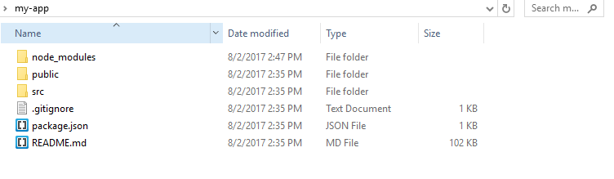

Modules:-

React module:-

* React
* react-dom
* webpack 🡪default
* babel-loader 🡪 default
* babel-preset-es2015 🡪es5,es6 default
* babel-preset-react 🡪 default

Routing:-

npm i --save react-router-dom